**Item Category Master**

* PURPOSE OF THE Item Category Master.

“Item Category Master” is used in “Supply Master”.

1. Select “Item Category Master” Menu Path :-Masters-> Pharma Retails Masters--> Item Category Master.

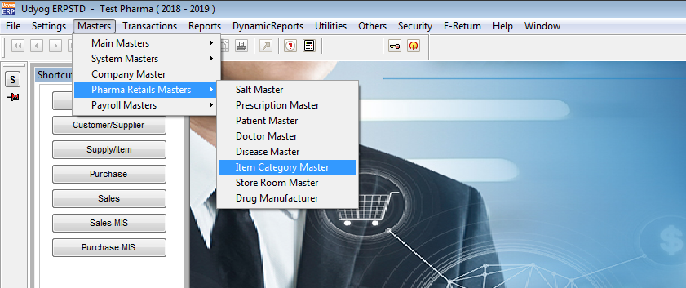

2.After Click On “Item Category Master”

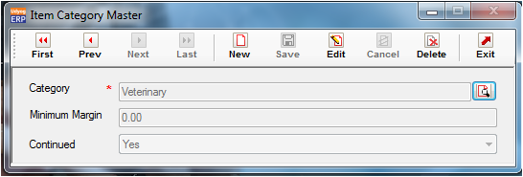

3.click on “Category search”, Category name are available in default.

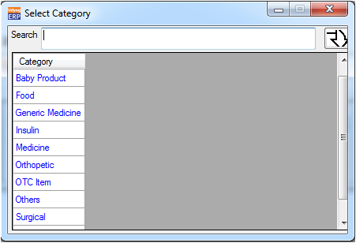

4. Validation list.

1. Duplicate Record not allowed.